Ku Klux Klan
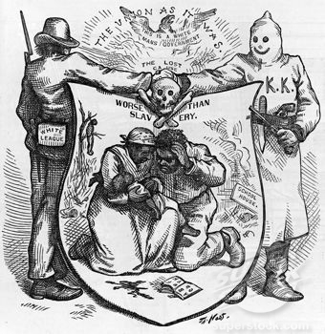
Answer the questions below after carefully studying the picture above.
1. Briefly describe the five people you see in the drawing.

2. There are four captions on or above the shield. What general message do you think they are trying to give?

3. Do you think the artist was in favor of or against the KKK? Why?

Carpetbaggers
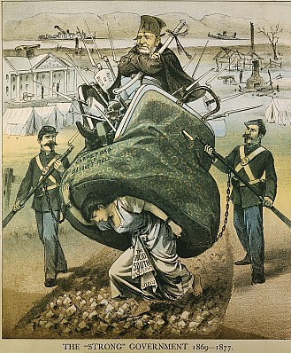
Answer the questions below after carefully studying the picture above.
1. Who is in control in this picture?

2. What is happening to the woman? Who do you think she represents?

3. What signs of destruction are there in the picture?

4. What do you think the artist’s opinion on Reconstruction was?

